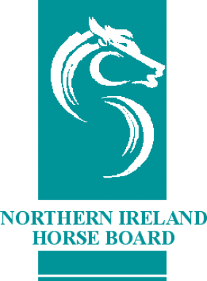
NORTHERN IRELAND HORSE BOARD
MEMBERSHIP RENEWAL 2020

To renew your NIHB membership, please complete this form and send it to the NIHB office along with the fee of £25.

NIHB

SECTION 1: MEMBER DETAILS

SECTION 1: MEMBER DETAILS

NIHB Shareholder No:
Name:
Address:
Postcode:
Telephone No:
Mobile No:
Email:

SECTION 2: DECLARATION

Please tick this box to confirm that you have read, understood and agree to the NIHB Terms & Conditions and consent to:
- Your data being entered onto the NIHB database
- Receiving communications from time to time in relation to NIHB business matters (eg. Shareholder renewals, AGMs, studbook publications etc.)
- Your data being shared with Horse Sport Ireland, for the purpose of receiving discounts on IHR passport applications.

Signature: | Date:

Payment Methods
Please see over leaf

SECTION 3: PAYMENT DETAILS
Enclose fee of: £25

METHODS OF PAYMENT
- Cheque- Please make Cheques payable to ‘NIHB’
- Cash- Only Available in Office (Do Not Send Cash Via Post)
- Credit/ Debit Card- if posting please complete Credit/ Debit Card Payment Form

Once completed please return along with the appropriate fee to:
Northern Ireland Horse Board
Office Suite
Meadows Equestrian Centre
Embankment Road
Lurgan
Co. Armagh
BT66 6NE

