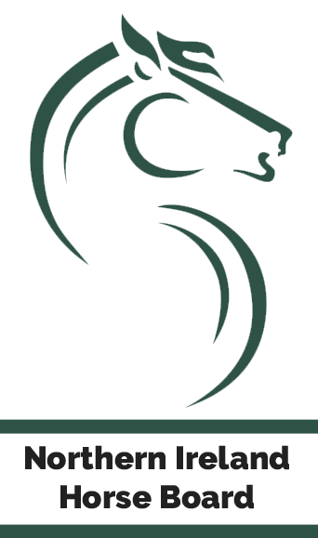

NORTHERN IRELAND HORSE BOARD

MARE DEVELOPMENT SERIES
2022

Supported by The Meadows Equestrian Centre
Northern Ireland Horse Board
Mares Development Series 2022

The Northern Ireland Horse Board are delighted to announce their NEW Mares Development Series for 2022, supported by the Meadows Equestrian Centre. Open to mares from all studbooks, it is hoped that the proposed competitions will facilitate the progressive training and development of mares in preparation for breeding careers later in life.

There will be qualifying events held throughout Ireland, where all double clear eligible mares will qualify for the final to be held at Meadows Centre at their Autumn Championship Horse Show, scheduled for 24th -25th September 2022.

QUALIFIER VENUES ARE:
Connellhill – Date to be confirmed
Banbridge Show- Saturday 11th June
Cavan – Sunday 19th June
Castle Irvine/Enniskillen Show – Saturday 25th June
Omagh Show 1st/ 2nd July
National Balmoral Championships- Saturday 9th July
Meadows – Saturday 16th July
Portmore – Sunday 24th July

HORSE ELIGIBILITY
- Mares 4 years and over
- Horse must have a registered passport.
- Horse must be named on passport. It is the owner’s responsibility to ensure their details are correct with Northern Ireland Horse Board/ Horse Sport Ireland.
- Horse and rider must have current SJI membership, temporary tickets will not be eligible.
- Breeder details must be included in passport

Please note: Mare details will be retained by the Northern Ireland Horse Board.

QUALIFIER COMPETITIONS
- Class 1: 1m Mares Development
- Class 2: 1.10m Mares Development
- Class 3: 1.20m Mares Development
- All double clears will qualify
- The qualifiers may be incorporated into scheduled classes. Does not need to be run as standalone classes. These development classes are for all mares aged 4 years and upwards.
- Competition must have a minimum prize fund of £100.
- Standard SJI entry fee is applicable in the qualifiers.
- Qualifying events must be run under SJI rules
- Competition Articles
  - 1m Article 274.5.1/ 274.5.2
  - 1.10m & 1.20m – Article 274.5.2 or 3 (Two Phase) or 238.2.2 (Jump Off)
- Competitions may be run between April and August 2022.

MARE SHOW JUMPING MERITS
NI Horse Board Show Jumping Merits will be awarded to mares that have met the following criteria:
- 1st Place- Gold Star Merit
- 2nd Place – Silver Star Merit
- 3rd Place – Bronze Star Merit

Mares finishing in 4th- 6th placings will have ‘Finalist’ stamped in their passport.

FINAL
- Run in September at Meadows Equestrian Centre in Main Arena as stand-alone class.
- Preliminary finals will be held on 24th September with 25 qualifying for Grand Finale
- Preliminary Finals will be run under SJI article 274.5.3
- Grand Finals will be run as Jump Off classes under SJI Article 238.2.2.
- NI Horse Board will provide Rosettes, Rugs, and memento to winner in each class.

Total Prize Money in Final prize money will be awarded to 6th place.

1m Final
 |  | 1st | 2nd | 3rd | 4th | 5th | 6th
Owner | £750 | 300 | 200 | 100 | 50 | 50 | 50

1.10m Final
 |  | 1st | 2nd | 3rd | 4th | 5th | 6th
Owner | £750 | 300 | 200 | 100 | 50 | 50 | 50

1.20m Final
 |  | 1st | 2nd | 3rd | 4th | 5th | 6th
Owner | £750 | 300 | 200 | 100 | 50 | 50 | 50

